Tugas 1 Sistem Bilanga

NPM : 22552011130

Nama: Ade Hikmat Pauji Ridwan

Kelas: TIF 22 B

1. (22,7)10 = (........)2 = (........)4 = (........)8 = (........)16

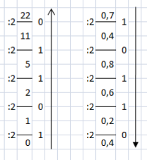

(22,7)10 = (10110, 10110)2 = (112,230)4 = (26,54)8 = (16,B0)16

1. (210,25)10 = (........)2 = (........)4 = (........)8 = (........)16

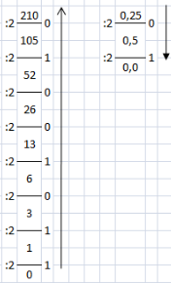

(210,25)10 = (11010010,01)2 = (3102,1)4 = (322,2)8 = (D2,4)16

1. (23,02)4 = (........)2 = (........)8 = (........)16 = (........)10



(1011,0010)2 = (1 x 23) + (0 x 22) + (1 x 21) + (1 x 20) + (0 x 2-1) + (0 x 2-2) + (1 x 2-3) + (0 x 2-4)

= 8 + 0 + 2 + 1 + 0 + 0 + 0,125 + 0

= 11,125

(23,02)4 = (1011,0010)2 = (13,10)8 =(B,2)16 = (11,125)10

1. (940)10 = (........) 16

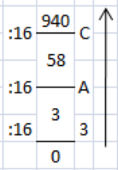

(940)10 = (3AC) 16

1. (5.600)10 = (........) 16

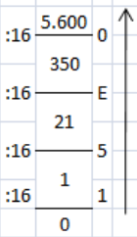

(5.600)10 = (15E0) 16

1. (1011 1001)2 = (........)4 = (........)8 = (........)16



 (1011 1001)2 = (2321)4 = (271)8 = (B9)16

1. (1111, 1101)2 = (........)4 = (........)8 = (........)16



(1111, 1101)2 = (33,31)4 = (17,64)8 = (F,D)16

1. (AB)16 = (........)2 = (........)4 = (........)8= (........)10



(10101011)2 = (1 x 27) + (0 x 26) + (1 x 25) + (0 x 24) + (1 x 23) + (0 x 22) + (1 x 21) + (1 x 20)

= 128 + 0 + 32 + 0 + 8 + 0 + 2 + 1

= 171

(AB)16 = (10101011)2 = (2223)4 = (253)8= (171)10

1. (BECA)16 = (........)2 = (........)4 = (........)8= (........)10



(1011111011001010)2 = (1 x 215) + (0 x 214) + (1 x 213) + (1 x 212) + (1 x 211) + (1 x 210) + (1 x 29) + (0 x 28 + 1 x 27) + (1 x 26) + (0 x 25) + (0 x 24) + (1 x 23) + (0 x 22) + (1 x 21) + (0 x 20)

= 32.768 + 0 + 8.192 + 4.096 + 2.048 + 1.024 + 512 + 0 + 128 + 64 + 0 + 0 + 8 + 0 + 2 + 0

= 48.842

(BECA)16 = (1011111011001010)2 = (23323022)4 = (137312)8= (48.842)10

1. (1258)10 = (........) BCD

(1)10 = (0001)2 -> (0001)BCD

(2)10 = (0010)2 -> (0010)BCD

(5)10 = (0101)2 -> (0101)BCD

(8)10 = (1000)2 -> (1000)BCD

(1258)10 = (0001 0010 0101 1000)BCD